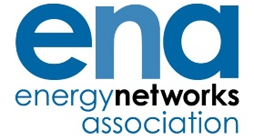
The Voice of the Networks

ENA Occupational Health Committee – Case Study

TITLE Musculo-skeletal disorders
These case studies are designed to outline the overall management of stress programmes within ENA member companies, and so identify different approaches to the management of this issue and examples of good practice.

Company Name: Northern Ireland Electricity Networks Limited (NIE Networks) 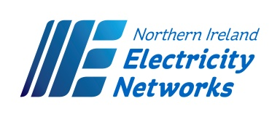
Company Initiative:
Provide ‘How Healthy is Your Back’ training sessions.
What did the Company do:
We worked along with a professional Physiotherapist to devise a programme which we initially delivered to office based staff at our annual Health & Safety Workshops. These sessions were so well received by staff that we delivered another series of sessions available to all staff during our annual Occupational Health & Wellbeing week in October.
From the positive feedback, we intend to increase the availability of these sessions into 2017.
Health and safety benefits:
- Increased awareness of good posture and general back health
- Increased knowledge of the spinal structure – the healthy spine
- Dangers of repetitive tasks and heavy lifting
- Good exercises to help keep a healthy back
- Key aspects of good posture and importance of well designed work stations
- Understanding of assessing manual handling activities
Business / Cost Benefits:
- Reduced injury and absence
- Identifying ‘at risk’ jobs and persons
- Improved information for staff therefore improving defence in potential claims
Employee involvement:
Very positive feedback from staff in general and via Company HESAC. Staff have requested specific sessions for linesmen, jointers etc and plans are being made to extend the programme into 2017 and possibly beyond. One employee stated in his feedback “The Musculo-Skeletal presentation was the best we have ever had in this company, everyone in our group really enjoyed it”.
Management View:
- A very useful training session so that manual handling activities and how a healthy back can be understood and achieved.
- Gives staff some easy exercises to help relieve tensions and counter potential back problems for the future.
- This Healthy Back programme has been very well received across the company and worth developing further for specific skills areas.

